Angular 2 Documentation

Local Setup

<https://angular.io/guide/setup>

[Download the QuickStart seed](https://github.com/angular/quickstart/archive/master.zip)

Go to quick start folder,

*npm install*

*npm start*

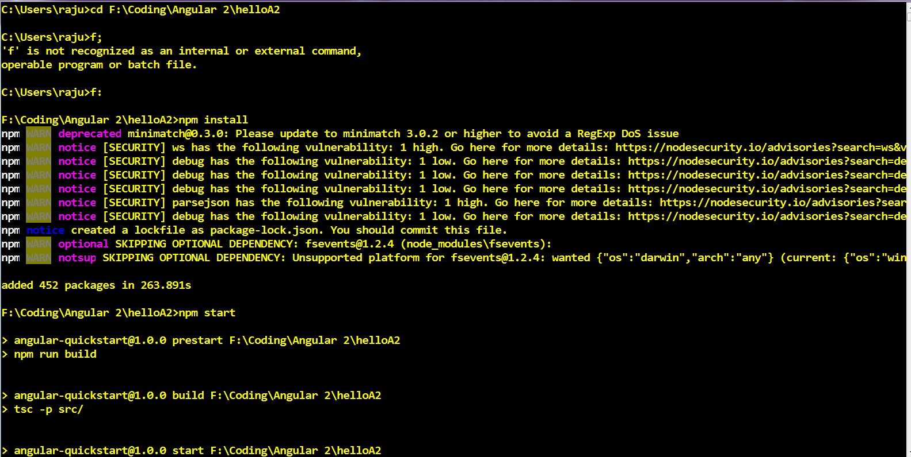

#### Creating Node Project

Create folder and use command

*npm init*

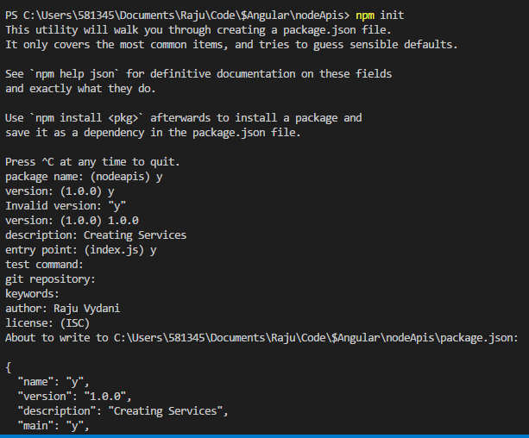

#### HTTP Server setup

npm install express --save-dev

npm install nodemon

Add below script in “package.json”

"scripts": {

"start": "nodemon",

"test": "echo \"Error: no test specified\" && exit 1"

},

*npm start*

CLI Setup

**Note**: This is for Angular 4

*npm install -g angular-cli*

*ng new <projectName>*

*ng serve*

*npm install -g angular2-cli*

*ng2 create hello_Angular2*

Tags used

[attr.colspan]="columnSpan"

[ngClass]='addClasses()'

[ngStyle]="addStyles()"

(click)="onClick()" / on-click="onClick()"

[(ngModel)]

Structural Directives

*ngIf='showDetails'

*ngFor="let employee for employees"

ng-container

ng-switch

ng-app

NgForm

### Various Bindings

|  |  |
| --- | --- |
| Interpolation | **{{ }}** |
| Property Binding | **[ ]** |
| Attribute Binding | **[*attr.colspan*]** |
| CSS Class Binding | **[*ngClass*]='addClasses()' [*class*]='classesToApply'** |
| Style Binding | **[*ngStyle*]='addStyles()' [*style.font-size.px*]="fontSize"-->variable in component class** |
| Two way data binding | **[ ( ) ]** |

Tutorials

Type Script Datatypes

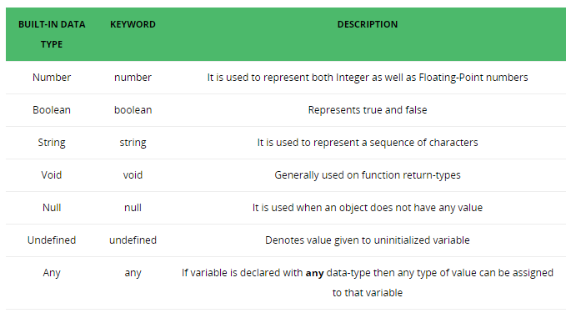

#### 1. What is a component 2. Creating a component and a nested component 3. Passing data between parent and child components using component input and output properties 4. Different ways of applying styles to components 5. We also discussed interpolation, property, class, style and event bindings 6. How angular two way data binding keeps component class properties and HTML element values in sync 7. Using angular structural directives ngIf and ngFor 8. Transform data before display using built-in angular pipes and creating our own custom pipes 9. How to create custom types for the business objects that we create in a real-world application like Employee, Customer, Order, etc using the TypeScript interfaces 10. Component Life Cycle Hooks 11. Creating a service that retrieves data from a remote web service 12. Using Bootstrap to style Angular components 13. How routing works in angular and passing parameters to routes 14. What is Dependency Injection and how it is implemented in Angular 15. How to work with Observables and Promises in Angular



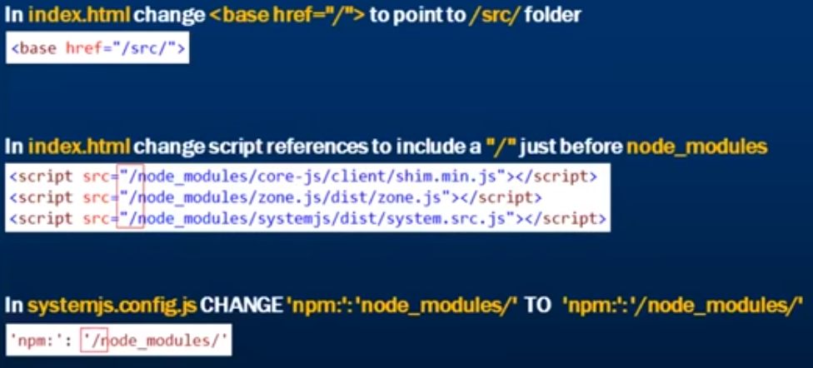

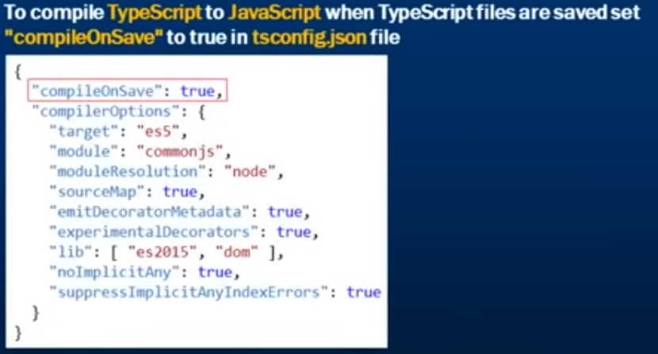

7-styles

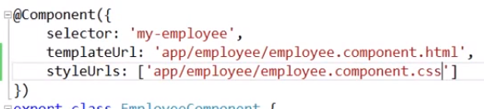

8-Interpolation

{{ <ClassvariableName> }} - Template expression

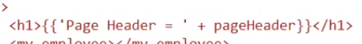

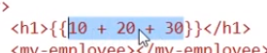



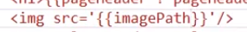

Calling method by interpolation

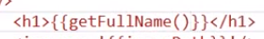

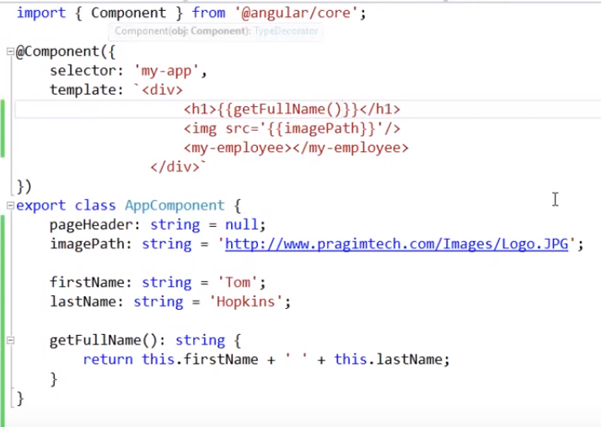

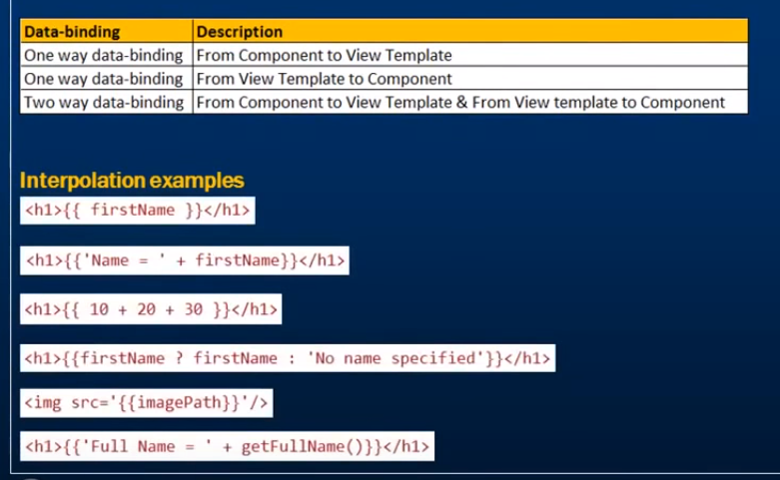

9-PROPERTY BINDING

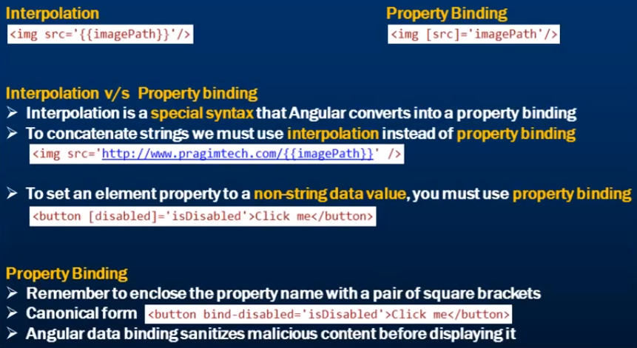

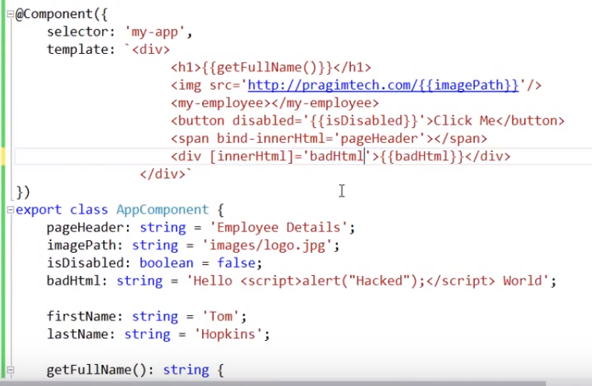



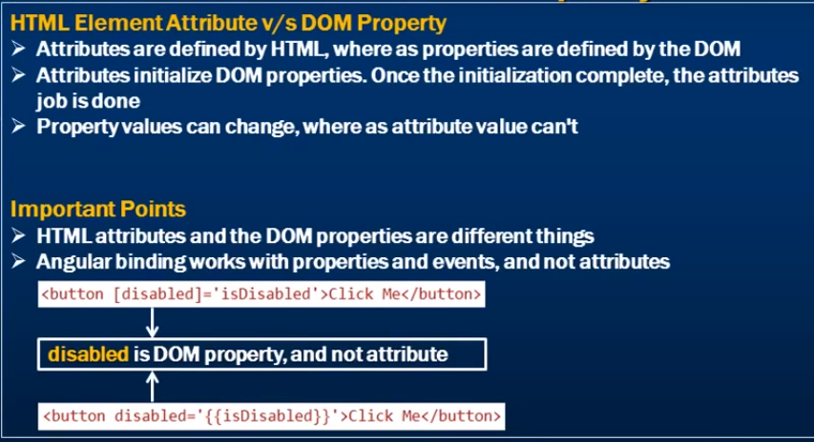



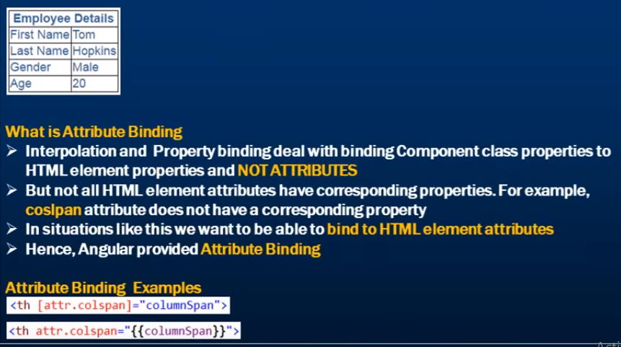



CSS Class Binding

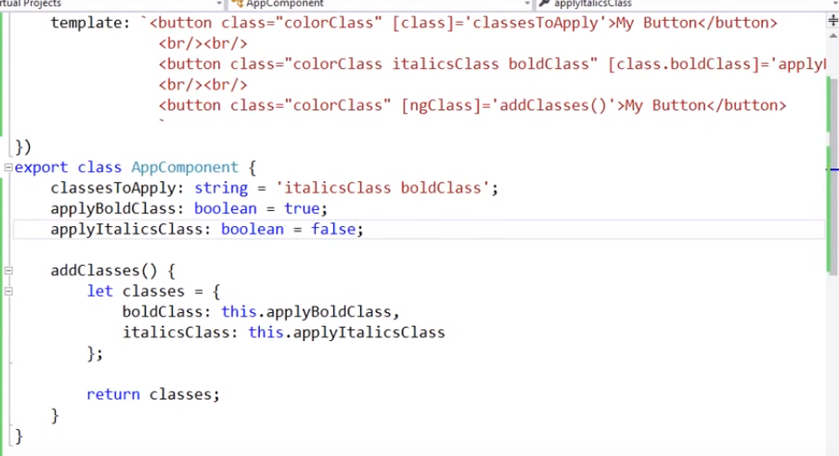

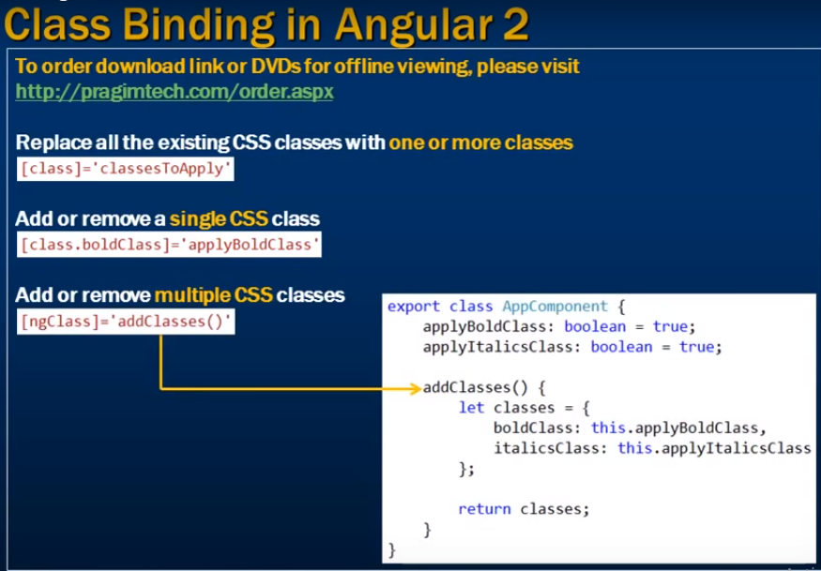



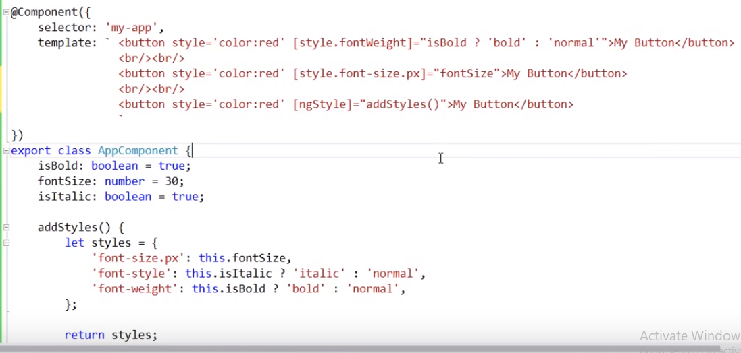



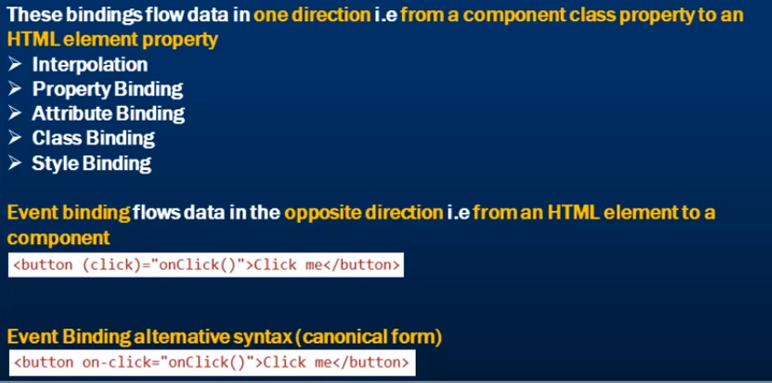

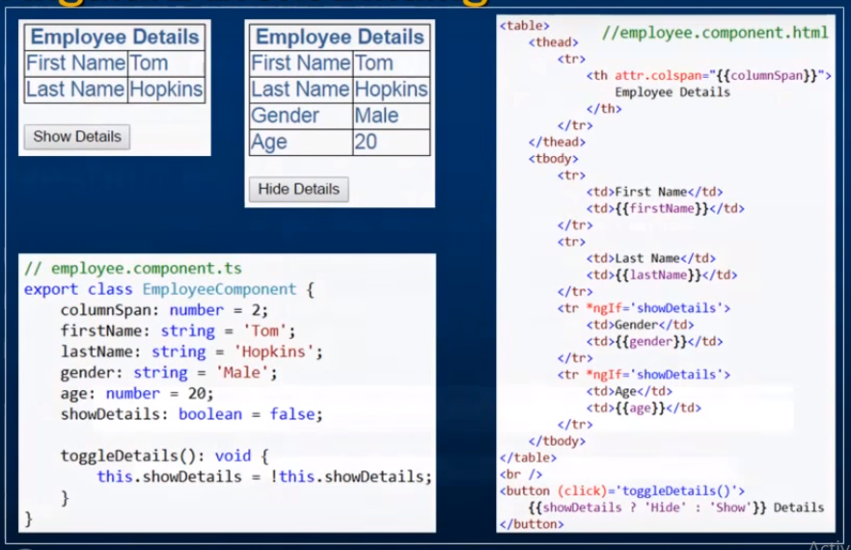



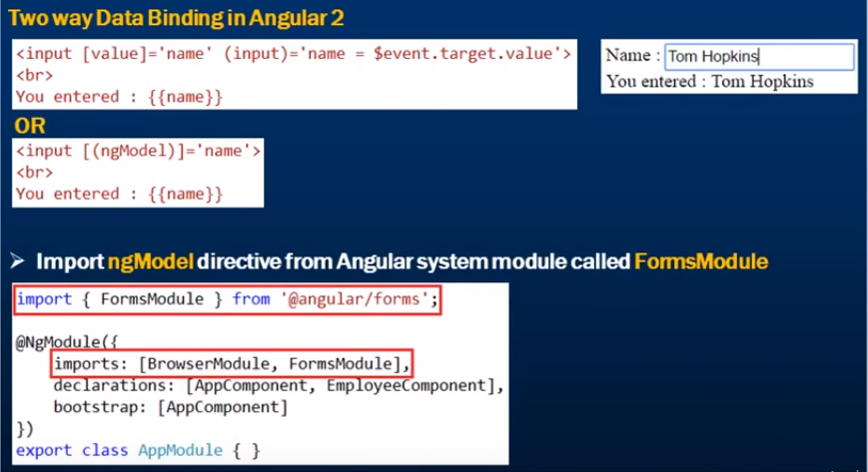

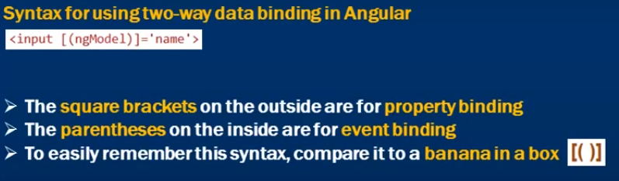



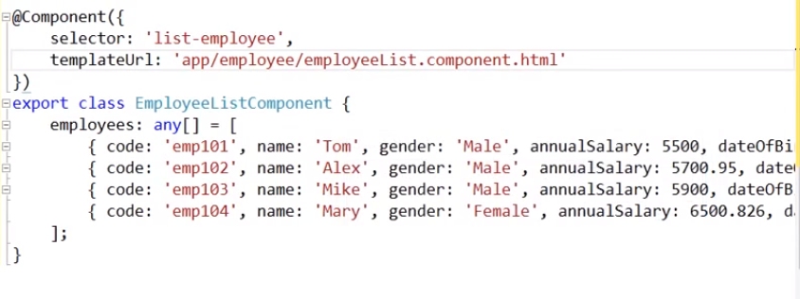

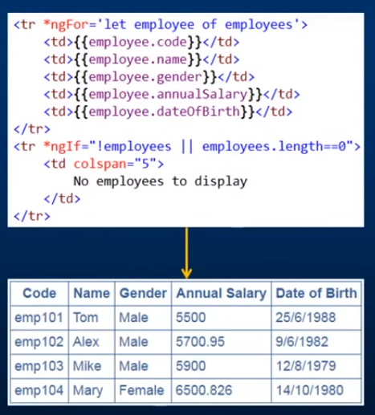



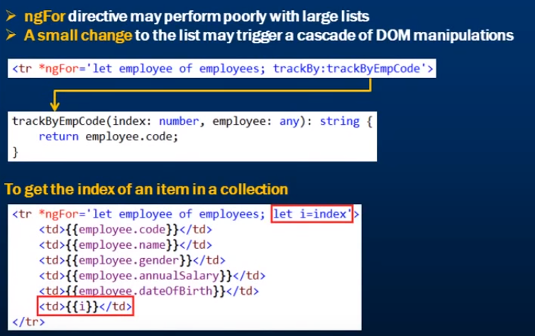

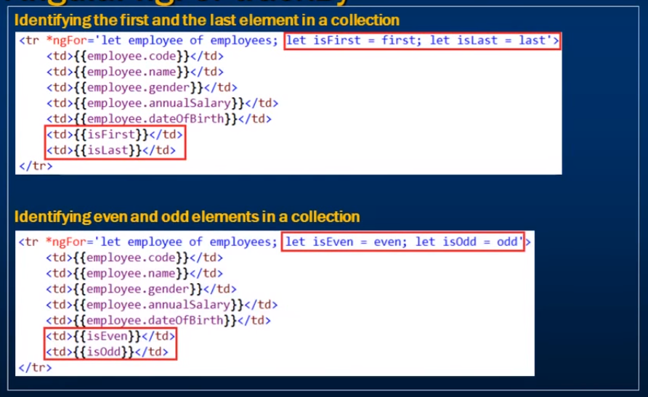



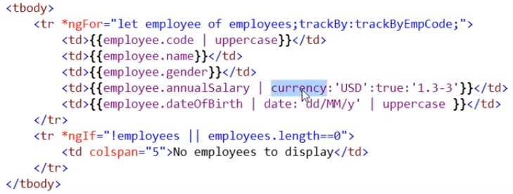

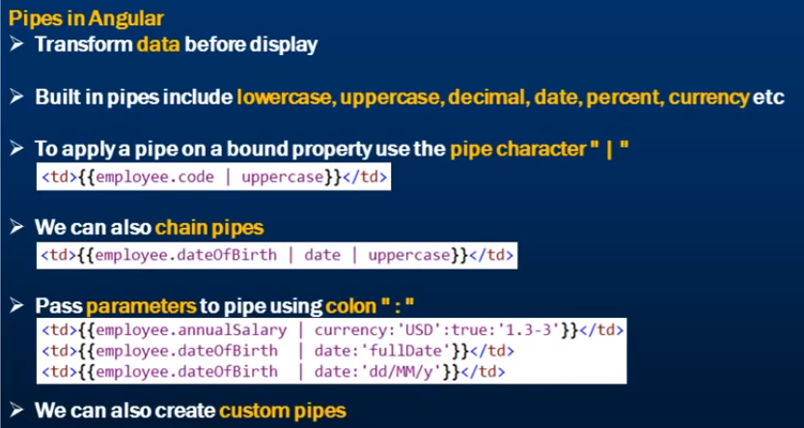



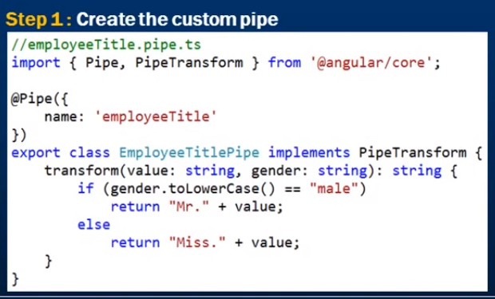

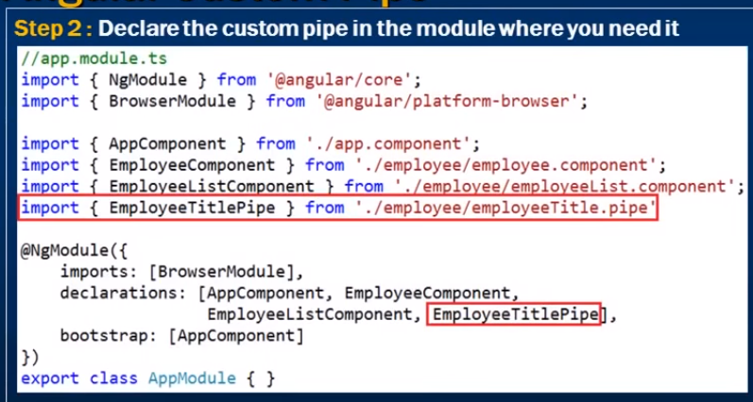

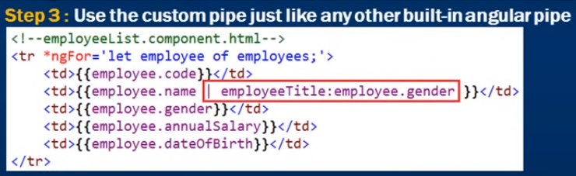



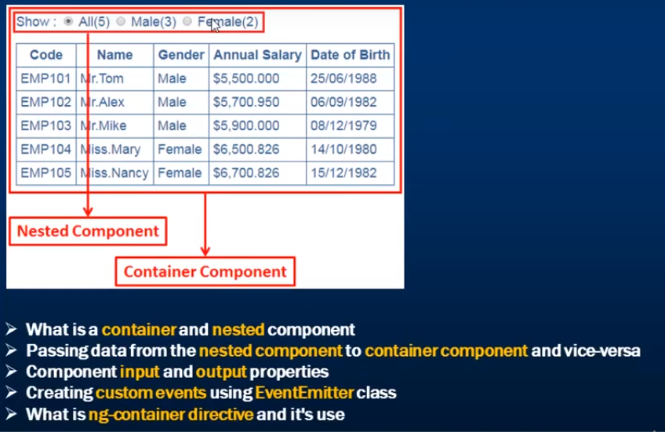



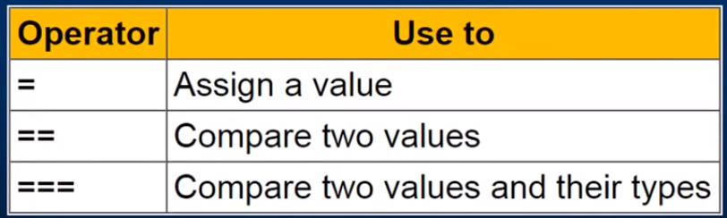

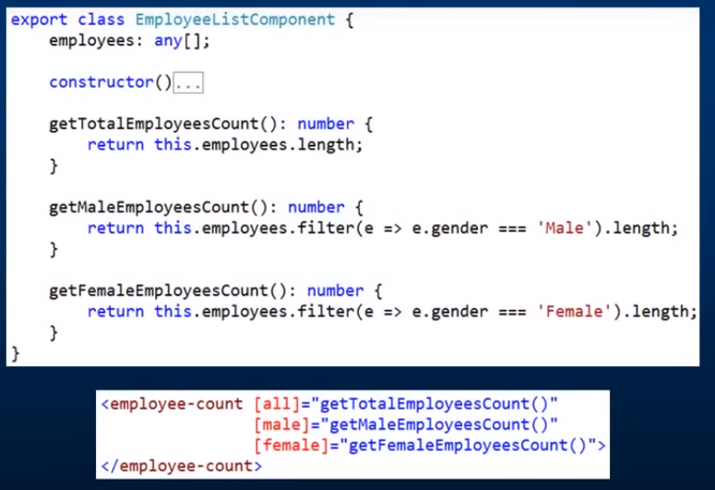



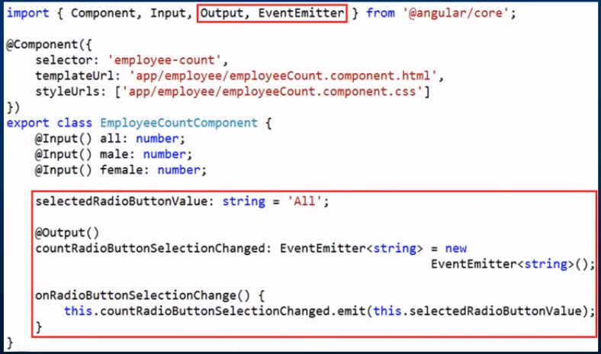

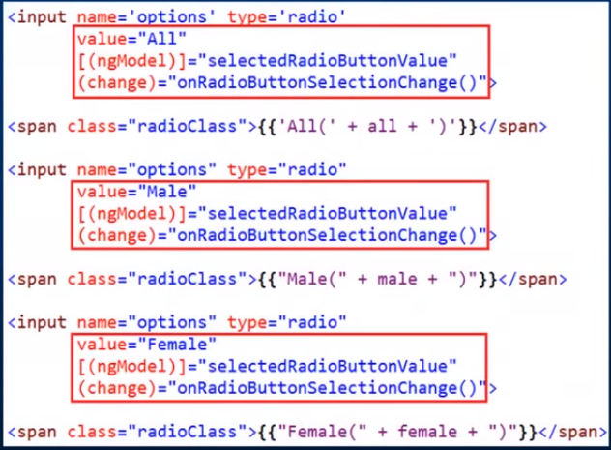

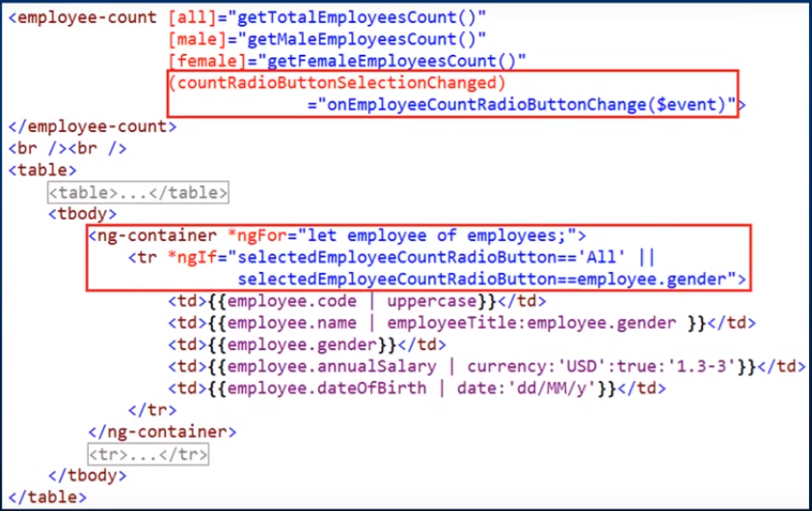We should not use 2 ng directives on single element(<tr>).

Here we need to use <ng-container> to accommodate multiple directives.

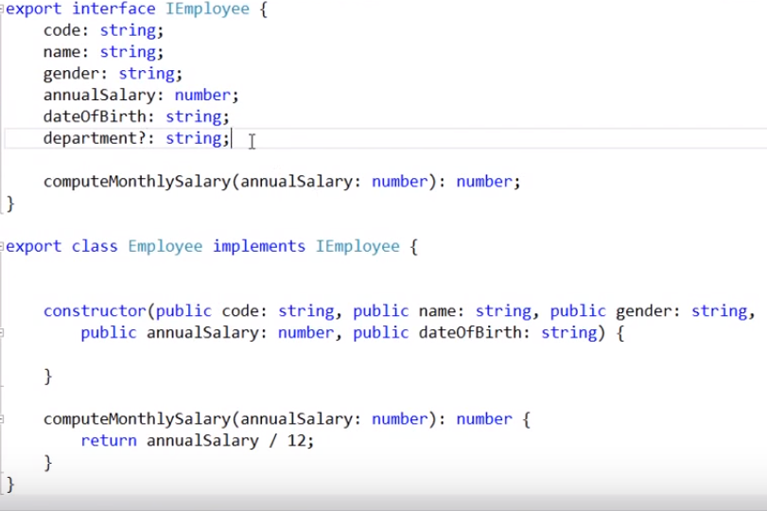

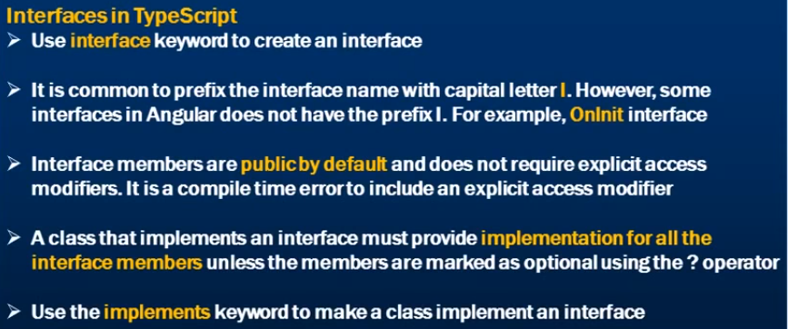

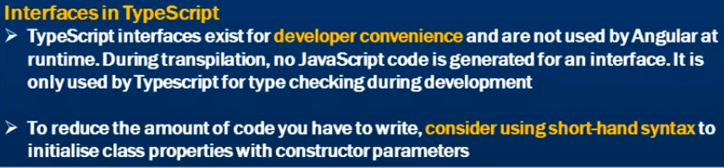



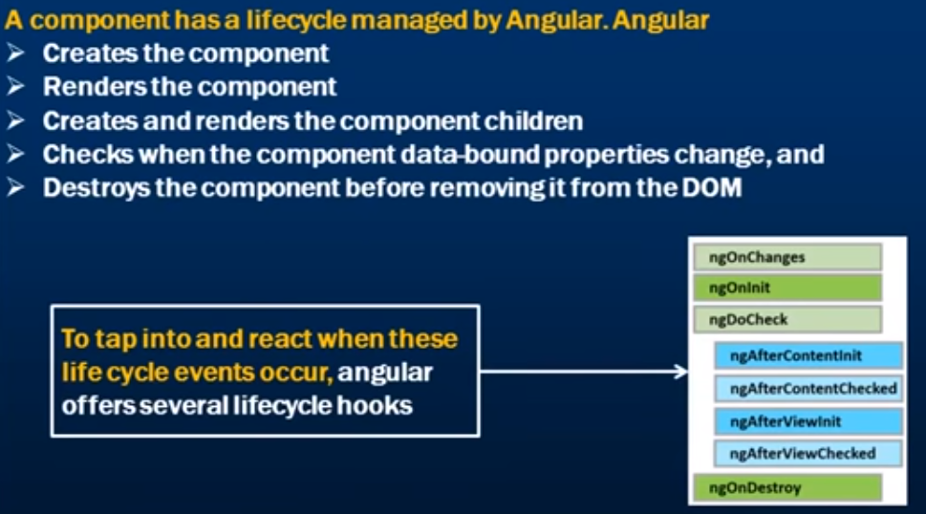

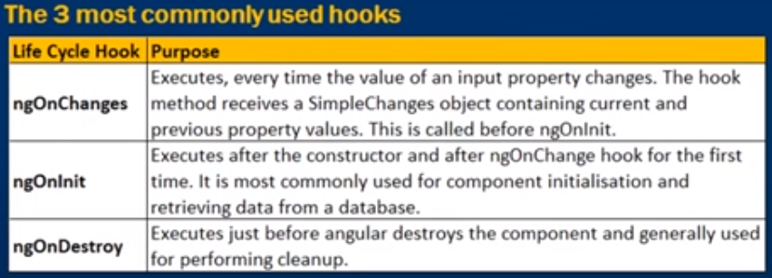

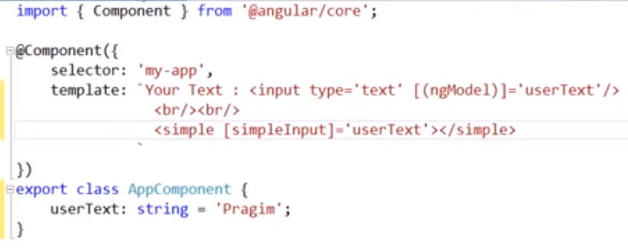

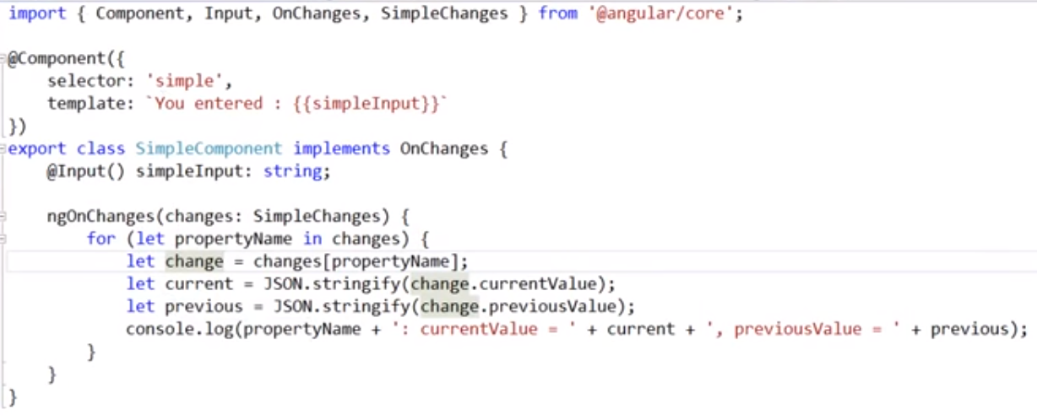

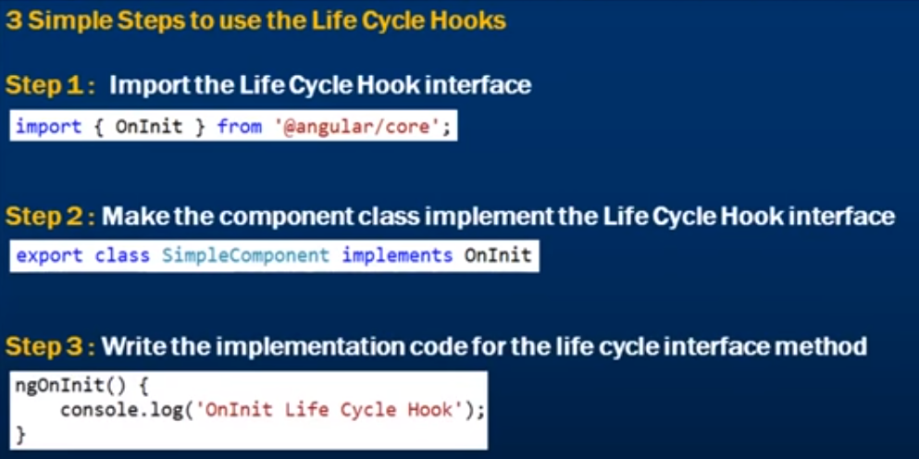





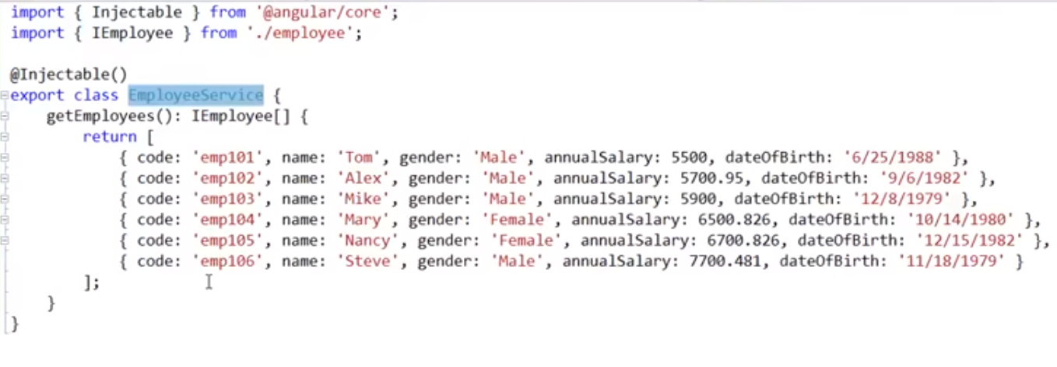

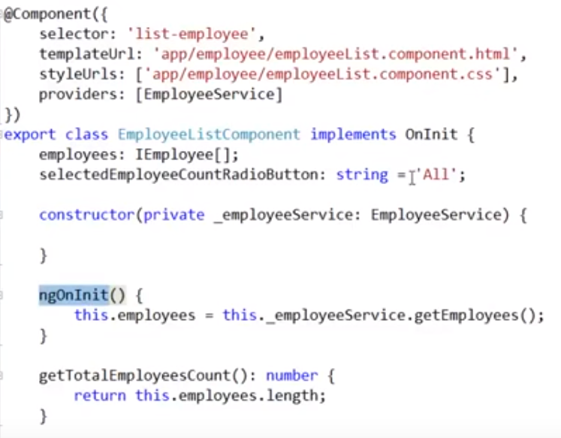

Concepts used here

providers

ngonInit

shorthand syntax

constructor

injectable

Dependency injection





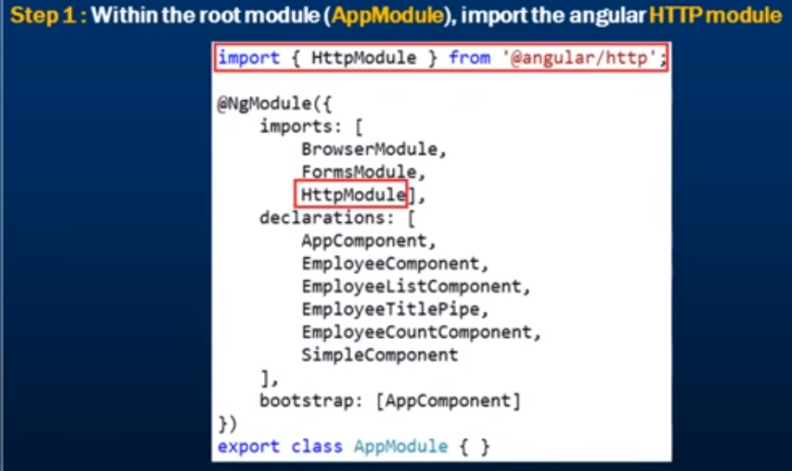

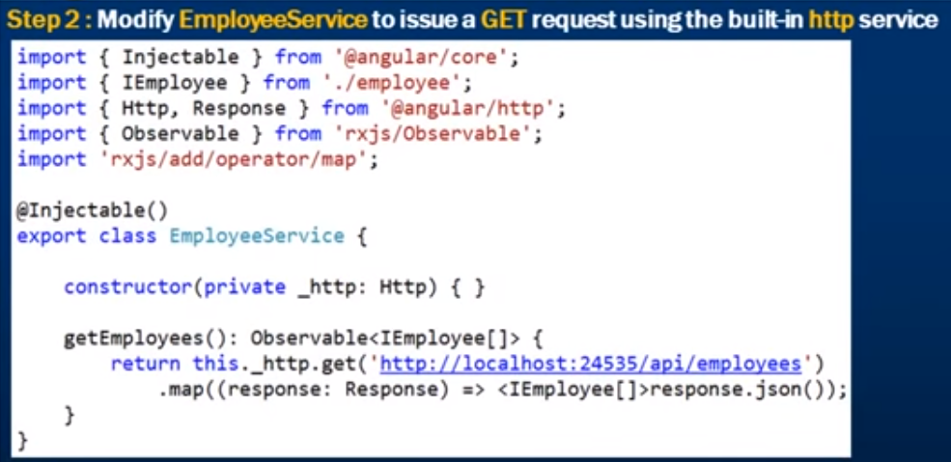

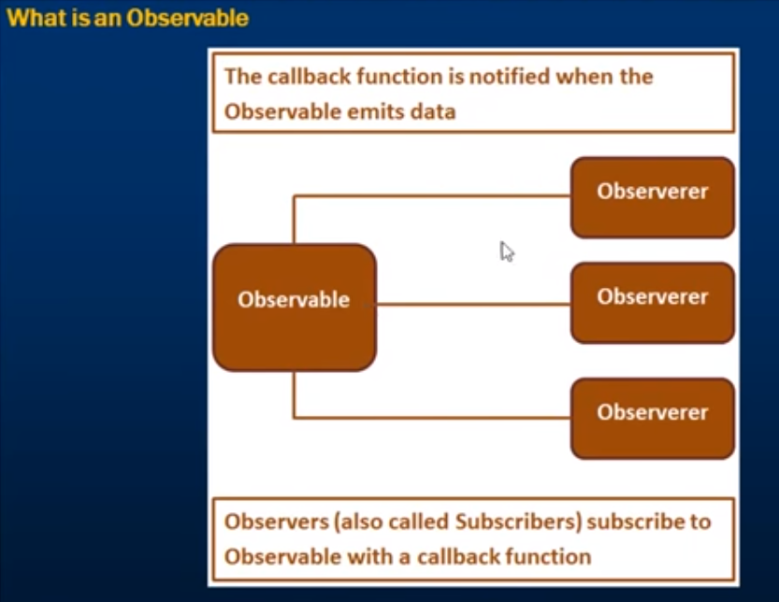

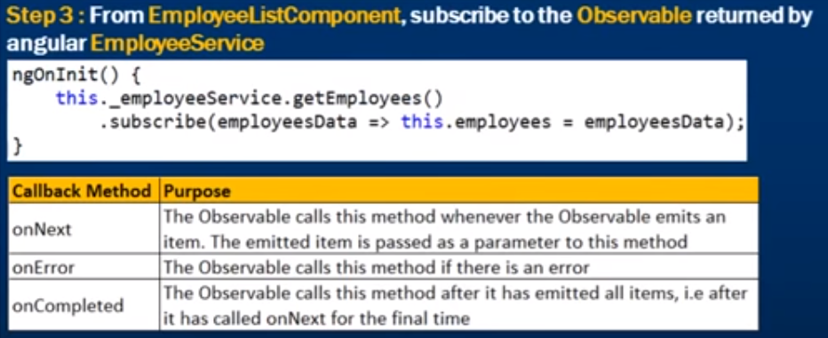



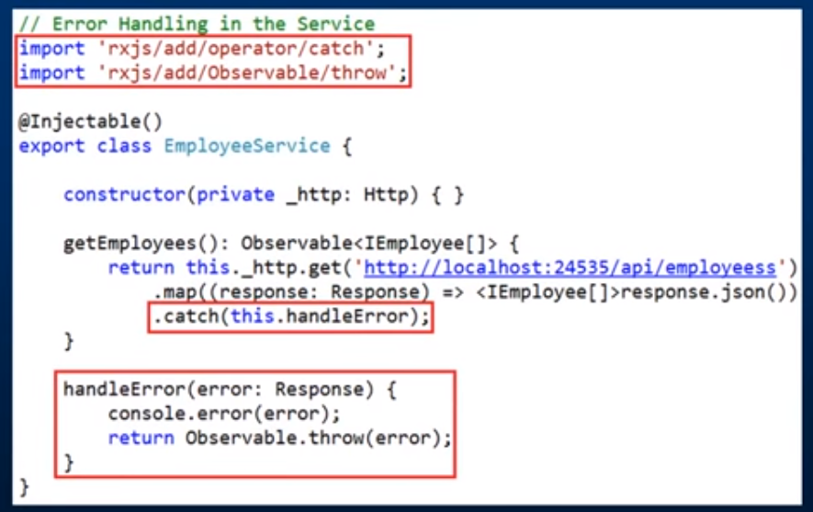

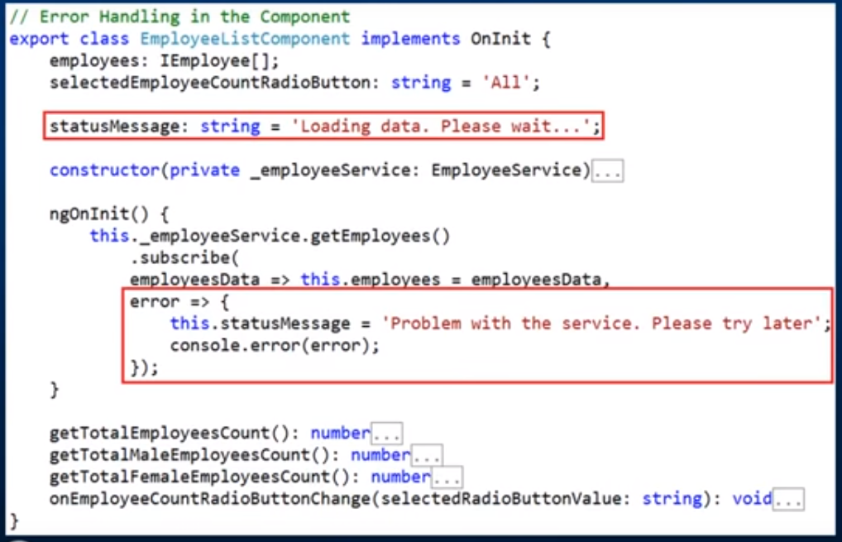





npm install bootstrap@3 jquery --save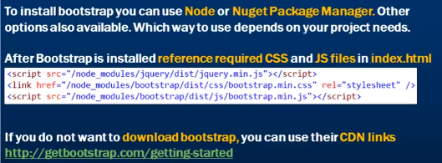



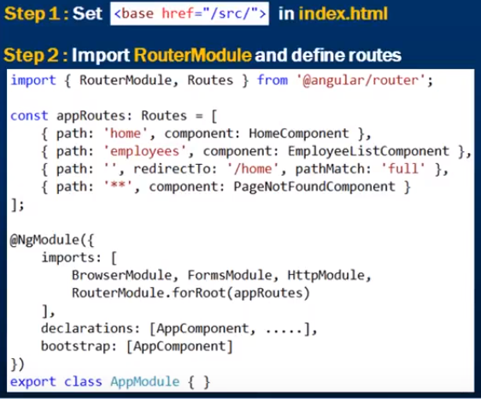

routerLink - Directive which will be provided by “RouterModule”

More Specific routes should be on top.

generic routes needs to be at bottom, otherwise all routes will be redirected to ‘**’ if this is on top.

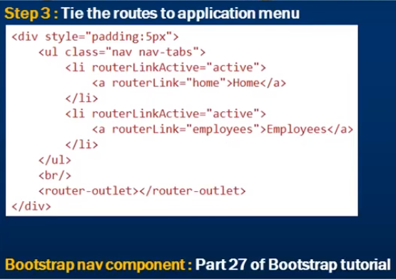

Routed pages will be placed in the tag **<router-outlet>**

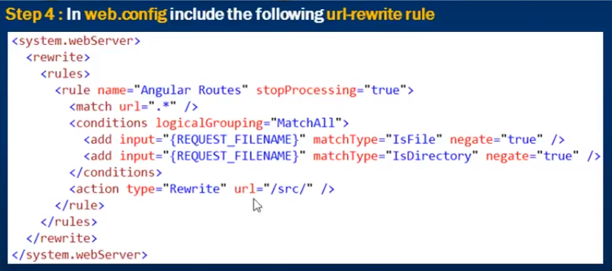

This configuration is provided basing on the server we are using. This is for IIS Server.

If we want to avoid above configuration, use #, need to use below “**UseHash**” property.





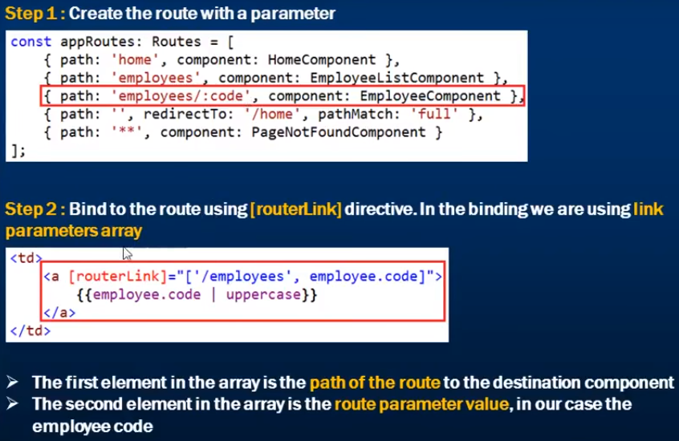

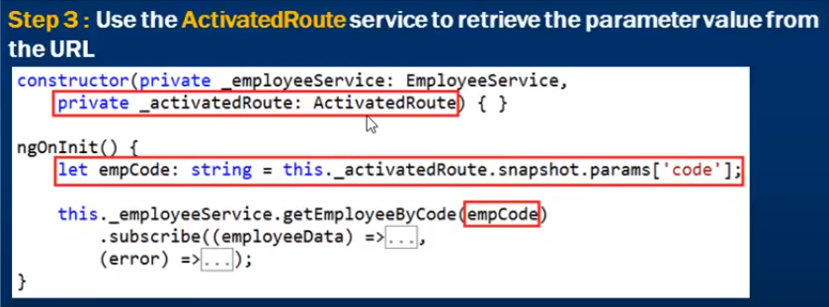

## Flow:

click on routerLink [send employee code via url ***employee/101***]

ng module - router configuration (redirection)

employee component



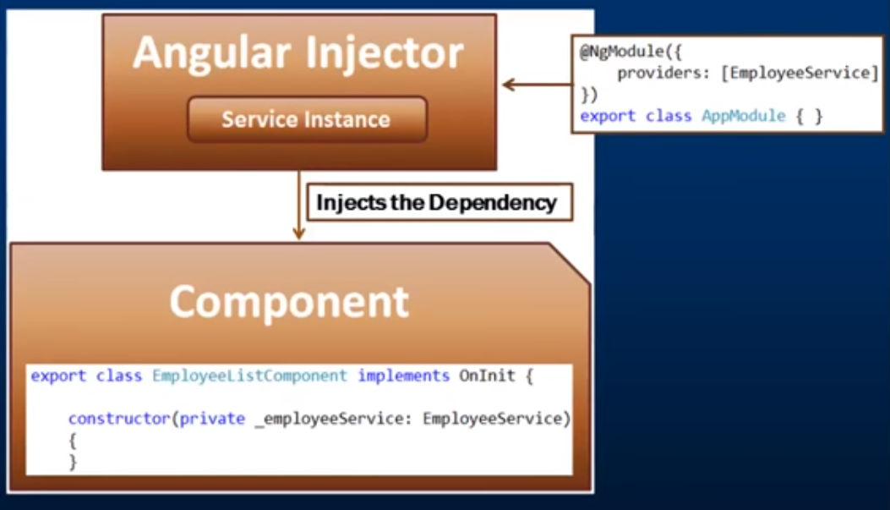

**providers** is used to tell angular which service needs to be injected





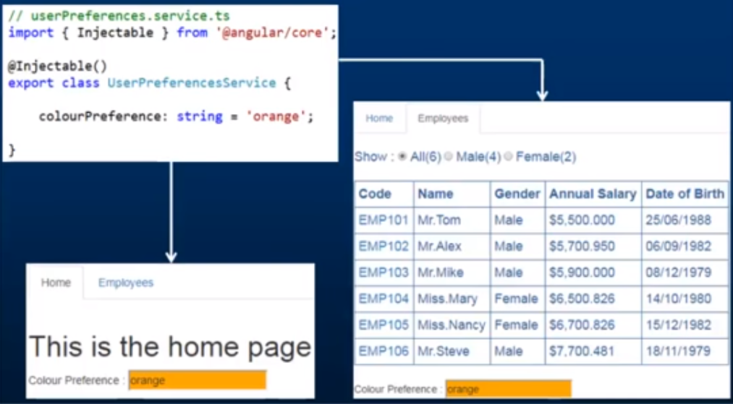



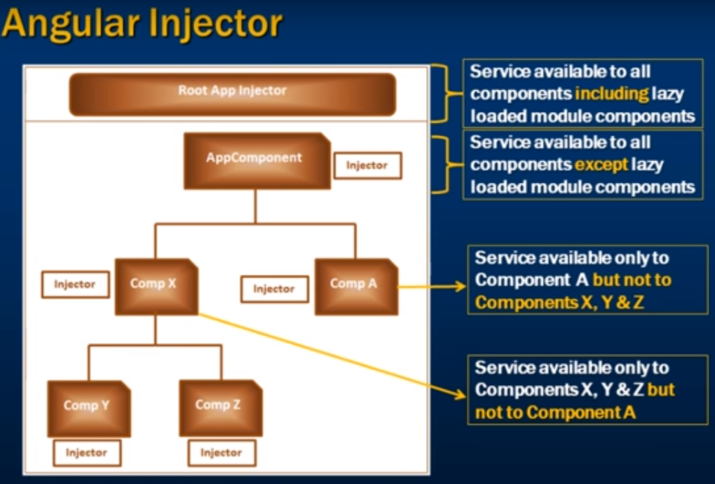

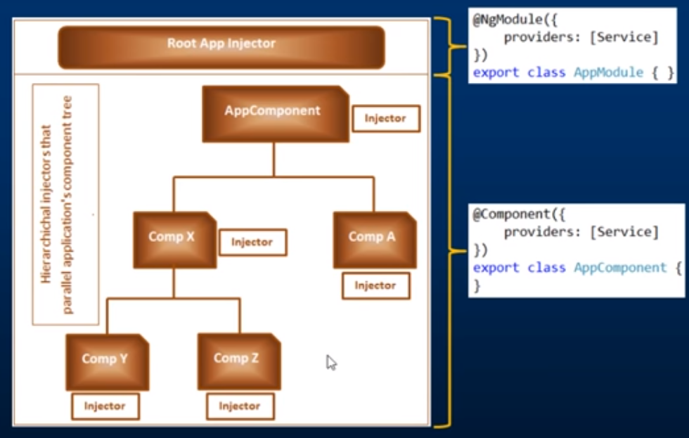





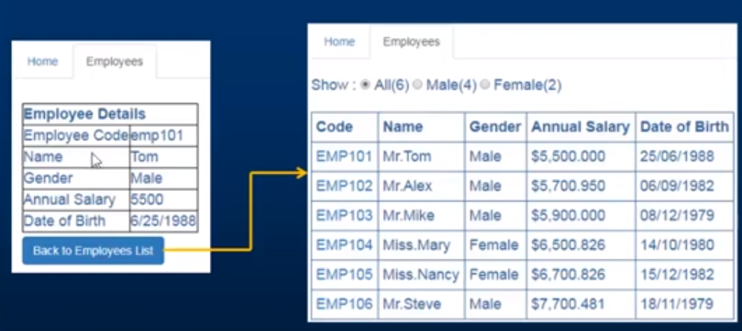

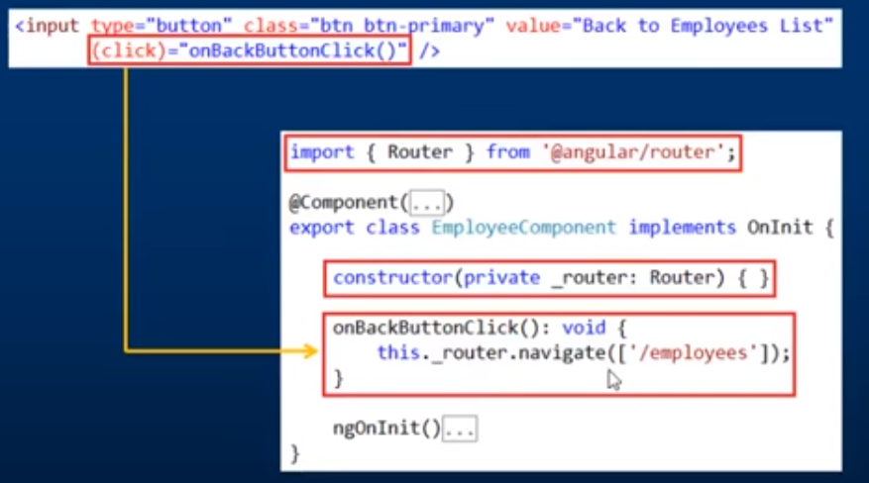



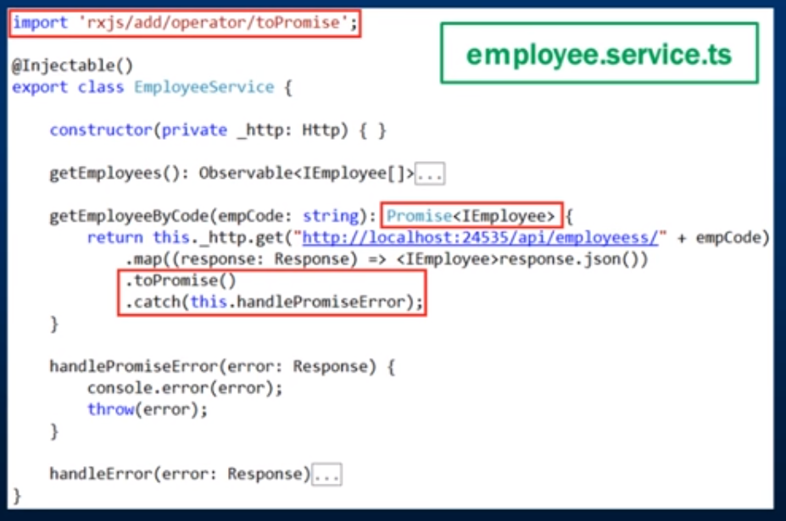

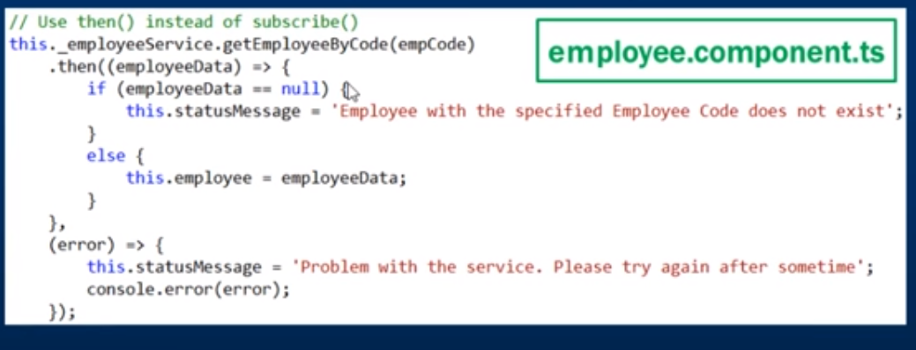



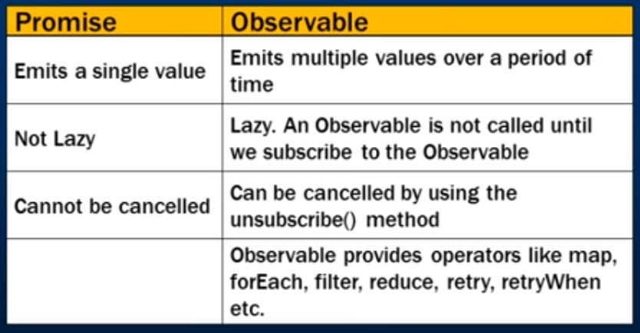



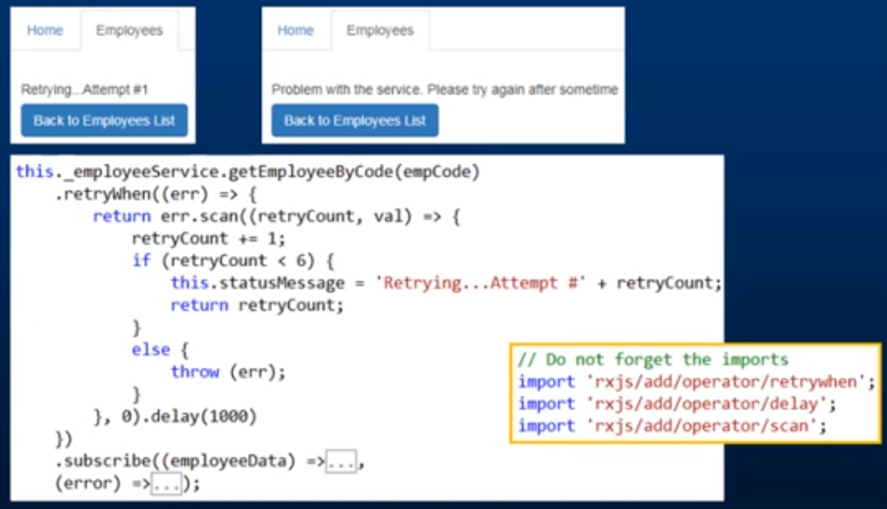



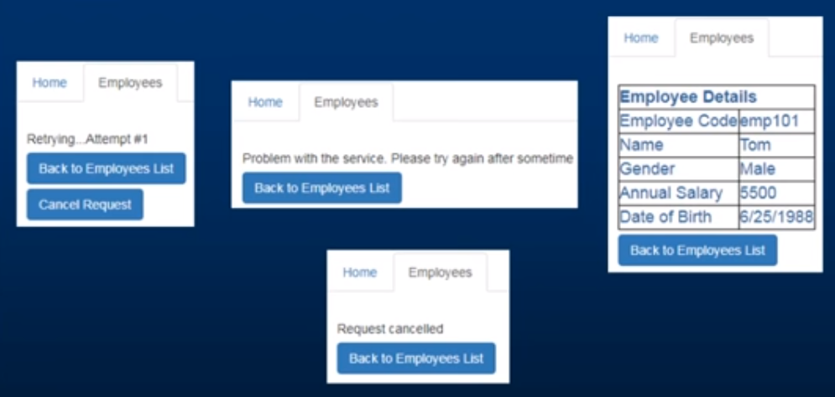

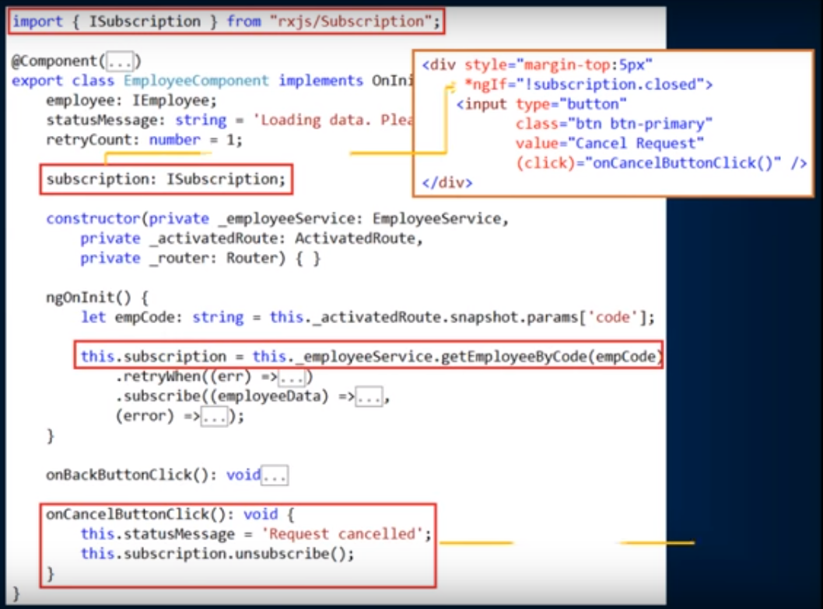

## Observables

retry

retryWhen

delay

scan

unsubscribe



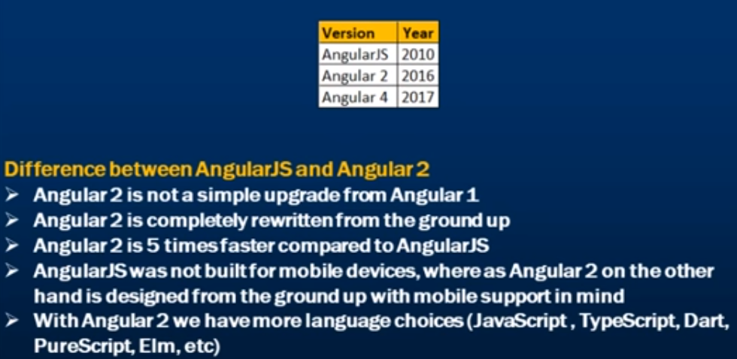

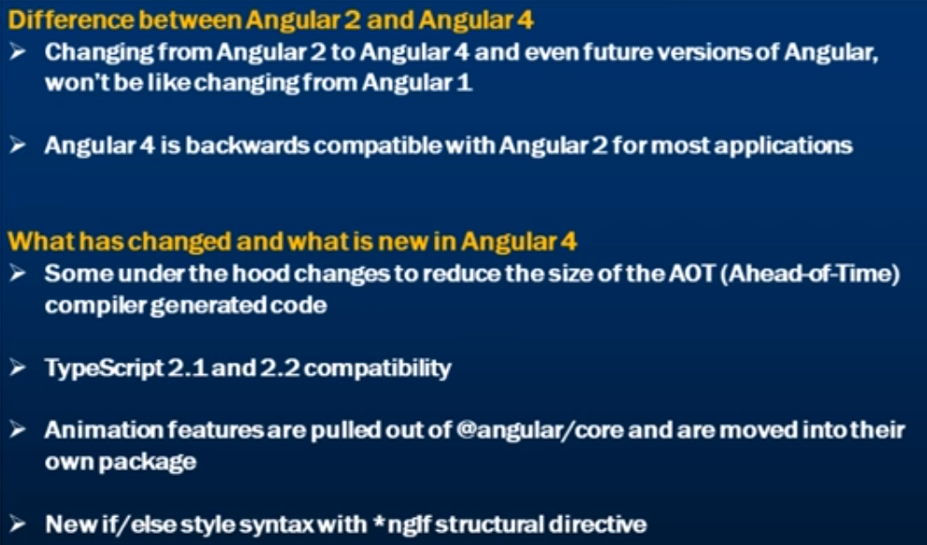

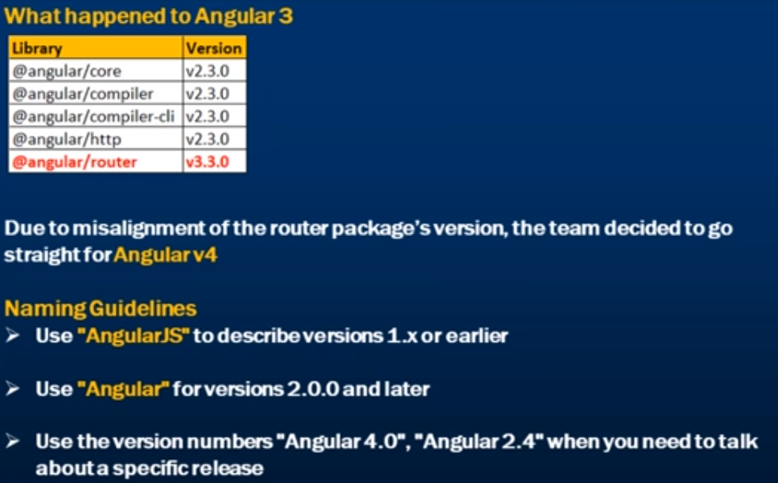



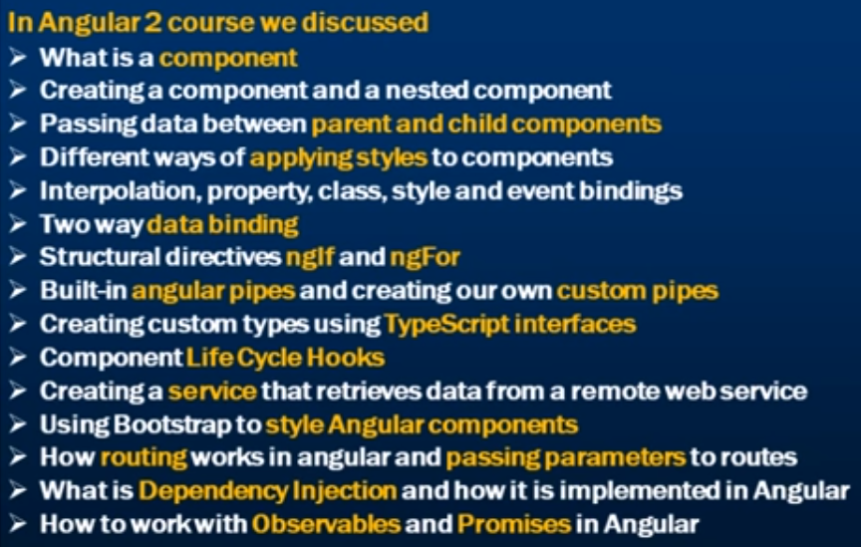

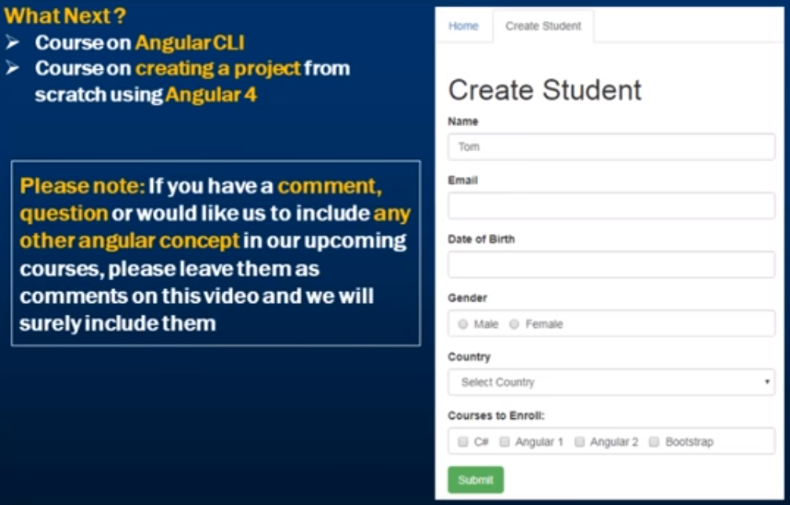



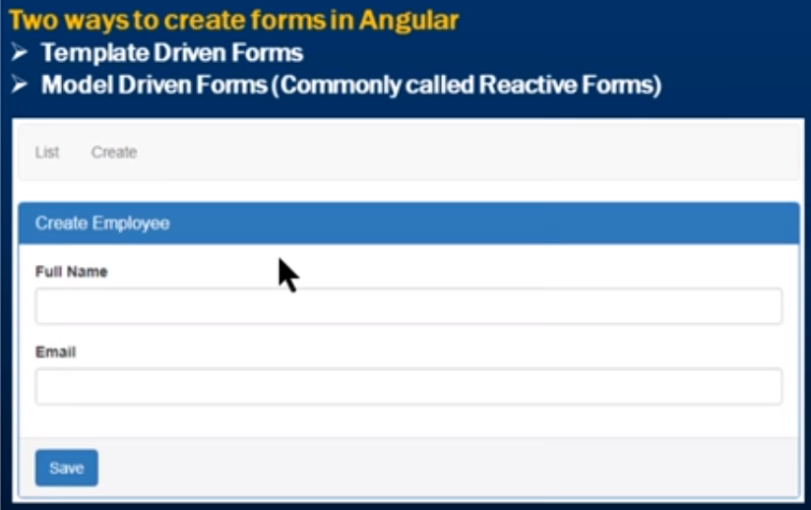

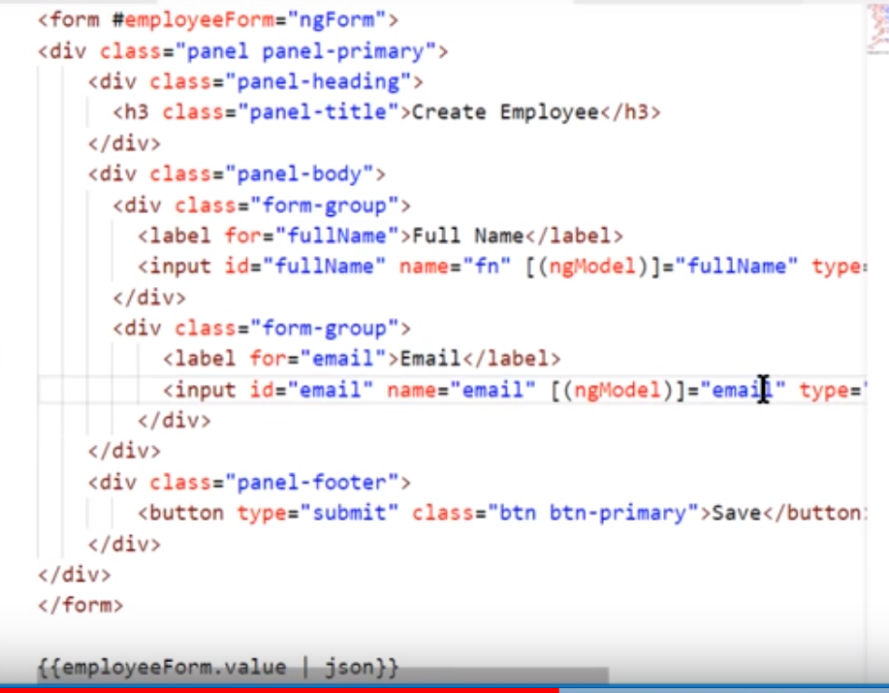

Practice

npm start

npm install bootstrap@3 jquery --save

Change index.html with bootstrap paths

<http://www.pragimtech.com/kudvenkat_angular2_tutorial_videos_download.aspx>

# 

# 

# ng-book 2

Install node js

$ npm install -g 'typescript@1.9.0-dev.20160409'

1 npm run tsc // compiles TypeScript code once and exits

2 npm run tsc:w // watches for changes and compiles on change

npm run serve

To run Angular 2, we depend on these four libraries:

• core-js

• zone.js

• reflect-metadata

• SystemJS

shim.js - corejs ES6 shims Provides cross browser compatibality

Zone.js - detecting changes to data

Reflect Metadata

Angular itself was written in Typescript, and Typescript provides annotations for adding metadata to code. Roughly speaking, the reflect-metadata package is a polyfill that lets us use this metadata.

#### SystemJS

SystemJS is a module loader. That is, it helps us create modules and resolve dependencies. Module loading in browser-side javascript is surprisingly complicated and SystemJS makes the process much easier.

* If you have a background in Angular 1, Components are the new version of directives.
* declarations defines the components in this module.
* imports describes which dependencies this module has.
* Remember that Angular can run on different platforms and so when we say platformBrowserDynamic() we’re telling Angular that we’re using a browser and we want to compile Angular “dynamically” (e.g. when we open the page in our browser vs. ahead-of-time compiling, which we’ll talk more about much later).
* platformBrowserDynamic().bootstrapModule(HelloWorldAppModule);
* *ng-repeat* directive from angular 1 is replaced with *\*ngFor* in angular 2
* *string[]* can be written as *Array<string>*

### Forms in Angular2

FormControls

Validators

Observers

**FormControl** and **FormGroup**.

FormModules gives us

**ngModel**

**NgForm**

ReactiveFormsModule gives us

**formControl**

**ngFormGroup**

NgForm -Directive

ngForm - Object of type *FormGroup*

***<form #f="ngForm"***

f - local variable for this view.

ngForm is of type ***FormGroup***

It is like

*Var f FormGroup;*

NgModel vs. ngModel: what’s the difference? Generally, when we use PascalCase, like

NgModel, we’re specifying the class and referring to the object as it’s defined in code. The

lower case (CamelCase), as in ngModel, comes from the selector of the directive and it’s

only used in the DOM / template.

There are a couple of different ways to specify ngModel in your templates and this is the first. When

we us ngModel with no attribute value we are specifying:

1. a one-way data binding

2. we want to create a FormControl on this form with the name sku (because of the name attribute

on the input tag)

### ***Forms*** Stopped at Page - 136

### HTTP

HTTP requests are asynchronous.

**Free Online APIs**

[**http://jsonplaceholder.typicode.com/**](http://jsonplaceholder.typicode.com/)

### ***HTTP*** Stopped at Page - 162

### Routing

**import { RouterModule, Routes} from '@angular/router';**

**const appRoutes: Routes = [**

**{path: 'login', component: LoginComponent},**

**{path: 'registration', component: RegistrationComponent},**

**{path: 'searchRoute', component: VideoSearch}**

**];**

**imports: [ BrowserModule, RouterModule.forRoot(appRoutes), FormsModule, HttpModule ],**

**<li routerLinkActive="active">**

**<a routerLink="searchRoute">Search</a>**

**<router-outlet></router-outlet>**

# Versions

4 - March 2017

5 - November 1, 2017